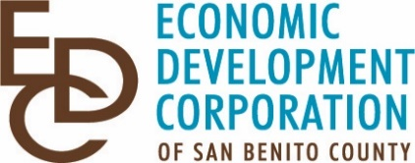

PRESS RELEASE
Contact: Marc Fontes, Executive Director
Economic Development Corporation of San Benito County
(831) 234-2044
mfontes@edcsanbenito.org
Hollister, CA March 24, 2020
SBA NOW ACCEPTING LOAN APPLICATIONS FOR DISASTER AND ECONOMIC INJURY
To get Started on an SBA LOAN APPLICATIONS Click Here: Cal Coastal

SBA Loan Application and Business Assistance
For assistance with your SBA loan application or other business needs contact the Cal Coastal Small Business Development Center (SBDC) 0ffice in Salinas through their website at:

Website: Cal Coastal
Email: sbdc@calcoastal.org
Phone: (831) 424-1099 Ext.3
Toll free number: 855-815-3833 Ext 3

Cal Coastal SBDC is your Best Resource for one-on-one professional help with your SBA loan application. Cal Coastal serves San Benito and Monterey counties, and is available at No Cost to your business! Their staff and business advisors are available to assist you by phone, email or video conference.
You must be a registered client to receive the no-fee services. Register at Cal Coastal, just Click the “Get Started” button and complete the registration for San Benito County businesses. Once completed, Cal Coastal SBDC’s professional staff will contact you directly to schedule the next steps to help you apply for the low-cost SBA loan for your business or other needed services. Cal Coastal SBDC’s professional staff are available to help you directly during these difficult times. Contact them Today!
###
About the Economic Development Corporation of San Benito County:

The Economic Development Corporation of San Benito County promotes economic growth and development in San Benito County, California through business attraction, retention, expansion and creation, while maintaining and preserving our agricultural land and rural environment. For more information, see EDC of San Benito County

